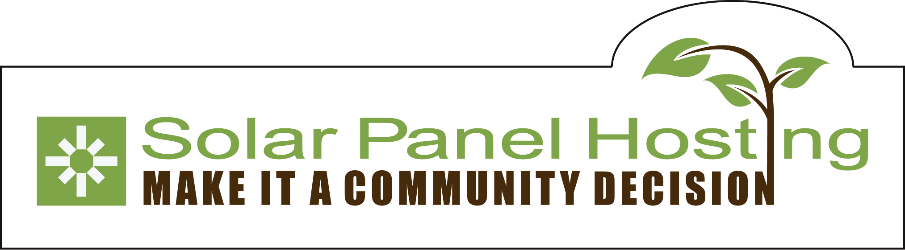
Solar Panel Hosting Company
Community Solar Gardens for XCEL Customers in Colorado

Joy Hughes, Solar Panel Hosting Company
4800 W. 80th Ave Suite 100
Westminster, CO 80030-4491
719.207.3097

The Solar Panel Hosting Company and the Solar Gardens Institute

The Solar Panel Hosting company (SPH) provides a comprehensive package for community supported energy development – coordinating planning, finance, construction, operations and maintenance, and subscriber management.



The Solar Gardens Institute (SGI) is a Colorado non profit, part of a national community power network. SGI organizes subscriber organizations, builds solar garden membership, and provides “solar gardener training” in solar development and community organizing to local leaders and volunteers.

Community Solar Gardens

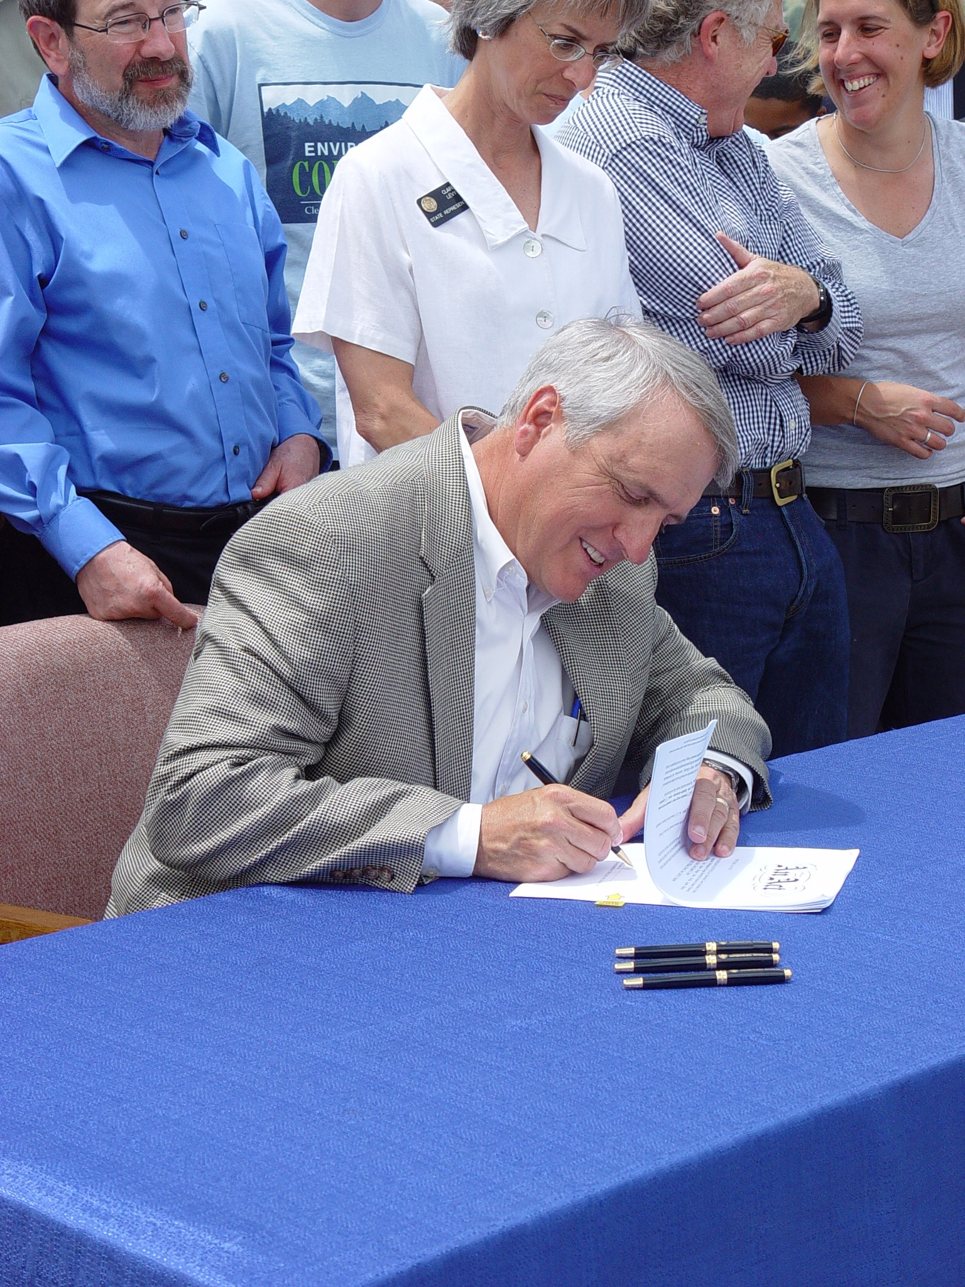
On June 5, 2010, Governor Bill Ritter signed the Community Solar Gardens Act. A solar garden is a community owned solar array with at least ten grid-connected “subscribers”. Each subscriber owns or leases a certain number of solar panels, and receives a credit for the electricity their panels produce. A subscriber may be an individual, a company, or a municipality – anyone with an electric bill.

Under the Act, the subscribers to a solar garden must reside within the same county or municipality and on the same utility service territory. (In counties with a population lower than 20,000, customers may subscribe to solar gardens in a neighboring county.) Subscriptions are portable for subscribers who move within the same county. The minimum subscription size is one kilowatt.

Municipal utilities and Rural Electric Cooperatives are not subject to the Act – in these areas, development of a solar garden is voluntary on the part of the utility.

The town of Saguache is an ideal site for a community solar garden for three reasons – the abundant sunshine, the heritage trees that make rooftop solar impractical for many buildings, and a citizen’s group organized for green energy.

Rule-Making at the Public Utilities Commission

On October 2010 the Colorado PUC commenced a rule-making process, which included a series of information gathering workshops, followed by a comment period and a hearing on March 18. On February 11, the Commission issued proposed rules, which are available on the solargardens.org website. As of early July, final rules are expected very soon.

Subscriber Organization

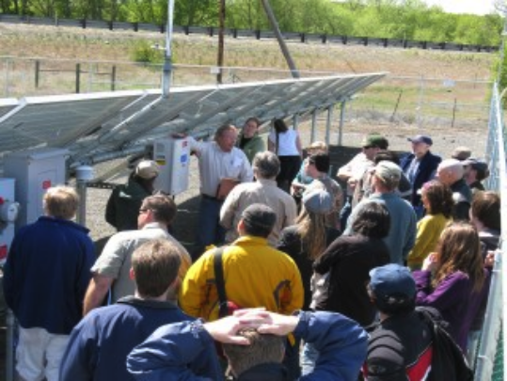
The Act allows a municipality, cooperative, or corporation (non profit or for profit) to serve as a subscriber organization. Subscriber organizations must be designed carefully to work within the federal and state securities laws that govern investments, and must be sure to access all available tax benefits so they can pass on savings to the subscriber. Subscriptions can be sold or transferred, with the subscriber organization acting as an intermediary.

SPH provides a ready-made subscriber organization, structured as a limited liability corporation, to handle subscriptions and maintain the equipment. We are developing a complete financial model for the LLC’s operations, based on the nation’s first community solar facility established in Ellensburg, Washington in 2006.

Limited income subscribers

The proposed rules include at least 5% of capacity reserved for “low income” subscribers at less than 185% of the poverty line, or who qualify for LEAP. One way to assure this is to make subscriptions available to customers in affordable housing apartments.

Solar Gardens Quota

During the first three years of the Community Solar Gardens program, the total capacity of solar gardens connected on XCEL territory in Colorado is limited to 6 megawatts each year, and for Black Hills customers, a significantly smaller amount. Capacity will be allocated through a queue, with a reservation deposit. In order to succeed, a given facility must be able to connect to the grid and have ten qualified subscribers ready to go.

At SPH, we have been paying close attention to the process as it develops. We can help to prepare a solar gardens application that we believe will have the best chance of approval.

Grants and Partnerships

Grant opportunities may exist that can be accessed by a public / private partnership. Community solar gardens in Colorado are a pioneering, high profile program that could attract grants not available to a more standard project. By working with local, statewide, and national non-profit partners, we may be able to raise funds to support low and middle income subscribers and for job training, enhancements, or up front costs.

For instance, by working with a community garden group, volunteers can provide edible landscaping for the solar garden. The new library district could sponsor a “renewable reading” program for kids and lectures for adults.

Project Development

The development and installation process will be supervised by NABCEP certified solar professionals, while involving the local solar workers, trainees, and the community in general. A signed letter of intent with the Garden Owner will begin the development process.

Site Selection and System Design

SPH will analyze potential sites to determine the approximate cost of connecting to the grid, aesthetic and security factors, and community preferences. XCEL will verify the connection may be made, and may charge a fee to determine if the grid will support a given interconnection. The system will be designed using high-quality equipment that has been UL rated and production tested. Optionally, the system may include features such as landscaping, a visitors’ kiosk, or public art to humanize the installation and make it an integral part of the community.

Project Costs

SPH will prepare a complete cost estimate, including equipment, labor, legal, insurance, finance, and hosting services. While the final rules are still uncertain, the cost for a one kilowatt residential subscription would be approximately $2200-2300, which in the San Luis Valley will produce over 1600 kilowatt hours of electricity per year. The subscription will continue to produce a credit as long as the panels last. A lease model allows a subscriber to begin realizing savings immediately. The chart below assumes electricity prices grow at an average of 5% per year.

Figure 1 – Approximate Cost and Return of Subscriber Lease
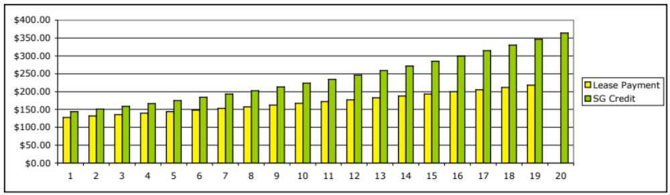

Local Development Team

In Fowler, CO, hundreds out of a population of a thousand turned out for the ribbon cutting on a community solar project. The installation and inauguration of a solar garden can be a community event, with the feel of a “solar barn raising”. While solar professionals handle the technical aspects, trainees and volunteers from the local community can participate in the site preparation, installation of panels, trenching and laying of conduit, etc. We plan to include local solar professionals as much as possible.

Operations and management

A solar energy system requires very little maintenance, including panel cleaning, weed control, and inverter replacements approximately every ten years. SPH will offer an operations and management plan that offers much of this occasional work to a local individual. The subscriber organization will carry insurance for low-probability events, such as hailstorms or vandalism.

Subscriber Organizing and Finance

Solar Gardeners

A Solar Gardener is a volunteer community organizer and renewable developer that works with the Solar Gardens Institute in a local area. SGI provides a “solar gardener training” that explains basic solar technology, community solar regulations, and the steps required to complete a renewable energy development. We will offer an in-person training in with a community meeting, conference calls, and web trainings as they become available.

Anchor subscriber

A larger electricity user, such as a municipality, public institution, or business can act to keep the solar garden fully subscribed by purchasing subscriptions that become available, and making them available to new subscribers. This will be especially helpful for new solar gardens that are still expanding their base of residential customers- as long as an initial ten subscribers are available. Under the proposed rules, a single subscriber may use up to 40% of the capacity of a solar garden (see example below).

Figure 2 - Solar Garden Ownership Percentage

New Subscriber Outreach

Each solar garden will have its own web page on solargardens.org that will include a list of subscribers and volunteers who wish to make their names public, project photos and plans, and a button that will let new supporters get involved. This will help local groups coordinate meetings between the members. SGI will make a press release in local media, and SPH may advertise for new subscribers. Word of mouth and social media will help build interest.

XCEL Standard Offer

XCEL energy proposed a standard offer program in its compliance plan for Colorado’s renewable energy standard. Solar garden subscribers will receive a credit on their electric bill each month equal to the production of their solar panels multiplied by the rate in the table below. Under this proposal, a residential customer (rate class R) would receive a credit of approximately 6.9 cents per kilowatt hour.

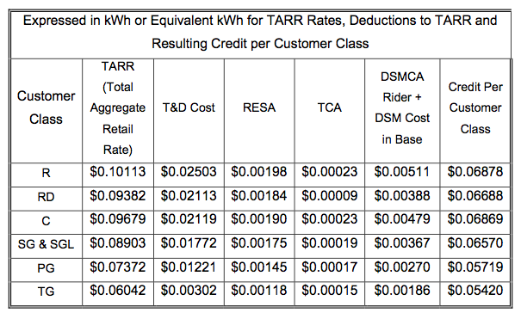
Figure 3 - XCEL Standard Offer Subscriber Bill Credits

XCEL will also offer a production credit to the garden owner as a payment for Renewable Energy Credits (RECs). A table of these payments is shown below.

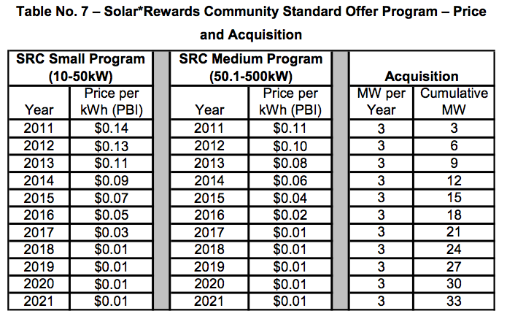
Figure 4 - XCEL Production Credit for Solar Garden RECs

Finance

Some people can afford to purchase their full subscription up front, while others might need to pay over time. Our goal is for our subscriber-members to gain ownership of their panels on completion of a lease term. The finance company, either Renewable Social Benefit Fund or a statewide cooperative, will lease the solar garden to the subscriber organization. The subscriber organization sub-leases the panels to the subscribers. In year 6, an ownership “flip” is possible, putting the solar garden into the ownership of a non-profit trust.

Appendix – Our Team and Advisors

Team

Joy Hughes founded the Solar Panel Hosting Company and the Solar Gardens Institute. Her background in the Silicon Valley startup world honed the agility and visionary skills to conceive and catalyze community based power arena. Joy is active in community energy organizing from the grassroots to the international level.

Joy comes from a research scientific computing background and prior to her involvement with renewable energy worked in biomedical, space, and computer graphics industries. She holds a BS in Engineering from Caltech and MS in Computer Science from UC Santa Cruz.

Greg Ching is instrumental in organizing the Nederland Renewable Energy Project, a proposal that was one of Claire Levy’s inspirations for the Solar Gardens Act. He organized an internet cooperative in Nederland and has been active in the FEED Denver Urban Farm.

Greg graduated with a Stanford BS Engineering (Computer Systems). After 5 years writing software for a telecommunications startup DAVID Systems, he moved to sales working for various Silicon Valley institutions such as PARC Place Systems and Sun Microsystems. He left Sun after 12 years for a Boulder startup Terma Software Labs.

Doug Southard is a NABCEP certified solar installer, bringing this perspective to the table along with 23 years of general contracting experience. Doug develops relationships with suppliers and industry groups, and manages the installation and maintenance of our solar energy systems.

Rachel Emmer received her MBA from the Bainbridge Graduate Institute, a premier green business school. She brings her project management skills in local food systems, community empowerment and transition movements, including gardening and food choice skills for Section 8 housing residents.

Becky English chairs the legislative committee at the Colorado Renewable Energy Society and the Sierra Club’s Energy Committee for Colorado. She has been instrumental on Solar Gardens policy with SGI. She holds a BA in Communications from CU and an MA from the University of Utah in journalism and mass communications.

Richard Deem has 35 years of experience as a CPA and tax advisor. His building in Westminster hosts our 10kW solar garden prototype. Richard does volunteer works sharing ethics skills with youth.

Advisors

Gary Nystedt of Ellensburg, WA, is credited for building the first community solar facility in the United States http://www.solar4rschools.org/schools/ellensburg-community-project, a utility-owned project which uses a leasing model. This project, which is now constructing its third phase, has served as a model for projects across

Anya Schoolman of Washington, D.C. founded the Mt. Pleasant Solar Cooperative http://www.mtpleasantsolarcoop.org, and is collaborating with the Solar Gardens Institute in founding a national community-based energy fund.

David Brosch of University Park Solar in Maryland http://universityparksolar.com/ focuses on constructing faith based community solar systems.

James Angel is a professor of finance at Georgetown University in Washington, D.C. His former career as a rate engineer at PG&E gives him a unique perspective on the complexities of utility pricing. When not advising us, he advises the U.S. Senate on financial crashes http://msb.georgetown.edu/story/1242666871500.html

